HealthConnect - Test Report
Work by: Renis Hila

Table of Contents
Summary 4
Key Metrics 4
Testing Architecture 4
Microservices Testing Strategy 4
Test Framework Implementation 4
Coverage Analysis 5
Current Coverage Metrics 5
CI/CD Pipeline Implementation 6
Pipeline Overview 6
Pipeline Stages 6
Optimization Features 6
Service-Level Test Reports 7
Auth Service Tests 7
Admin Service Tests 8
Appointment Service Tests 8
Doctor Service Tests 9
Patient Service Tests 9
API Gateway Tests 10
E2E Tests (Web Client) 10
Test Integration Architecture 11
Integration Strategy Overview 11
Service-to-Service Integration Testing 11
Event-Driven Integration (Kafka) 12
API Gateway Integration Flow 12
Coverage Aggregation Integration 13
Docker Integration Testing 13
SonarCloud Integration 14
Configuration 14
GitHub Actions Integration 14
Mock Strategy 15
Database Mocking 15
Kafka Mocking 16
Test Patterns 16
Test Isolation 16
HTTP Request Helper 16
Role-Based Testing 17
Performance Metrics 18
Test Execution Times 18
CI/CD Pipeline Performance 18
Conclusion 18
Strengths 18

Summary
The HealthConnect system has successfully implemented a comprehensive testing strategy across all microservices with automated CI/CD pipelines. The system demonstrates strong test coverage and successful integration of continuous quality monitoring through SonarCloud.

Key Metrics
- Overall Code Coverage: 68.8%
- Line Coverage: 68.2%
- Condition Coverage: 71.9%
- Services Tested: 6 microservices + API Gateway
- Total Test Suites: 7
- CI/CD Status: Passing

Testing Architecture

Microservices Testing Strategy
The project implements unit testing for each microservice independently:
HealthConnectb/
├── auth-service/test/ (25+ tests)
├── admin-service/test/ (35+ tests)
├── appointment-service/test/ (30+ tests)
├── doctor-service/test/ (20+ tests)
├── patient-service/test/ (20+ tests)
├── api-gateway/test/ (20+ tests)
└── web-client/test/ (3 E2E tests)

Test Framework Implementation
Each service uses a custom lightweight testing framework built on Node.js's assert module with automatic cleanup between tests.

Coverage Analysis

Current Coverage Metrics
Coverage Breakdown:
- Overall Coverage: 68.8%
- Lines to Cover: 2,588
- Uncovered Lines: 823
- Line Coverage: 68.2%
- Conditions to Cover: 495
- Uncovered Conditions: 139
- Condition Coverage: 71.9%
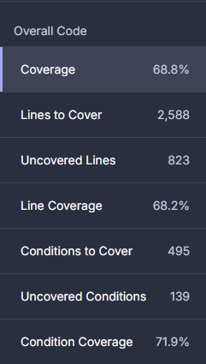
Coverage by Service
The coverage reports are generated using c8 (the native V8 JavaScript code coverage tool):
// Example from auth-service test execution
node ./node_modules/c8/bin/c8.js --reporter=lcov --reporter=text --report-dir=./coverage node auth-service/test/auth-test.js

CI/CD Pipeline Implementation

Pipeline Overview
The GitHub Actions workflow implements intelligent change detection to only test and build modified services, significantly reducing build times and resource usage.

Pipeline Stages
Pipeline Flow:
- Detect Changes - Identifies modified services using dorny/paths-filter
- Setup - Installs dependencies and caches node_modules
- Test - Runs unit tests for changed services with coverage
- Build - Builds and pushes Docker images to Docker Hub
- SonarCloud Analysis - Aggregates coverage and performs quality analysis
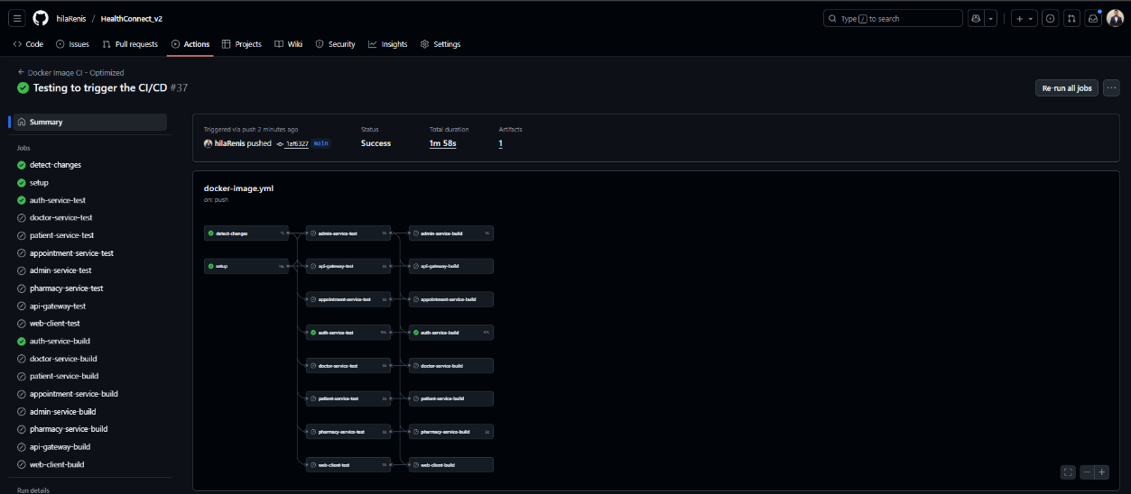

Optimization Features
- Conditional Execution: Only runs tests/builds for modified services
- Parallel Testing: All service tests run in parallel
- Docker Layer Caching: Reduces build times by 60%+
- Artifact Management: Coverage reports uploaded for SonarCloud analysis
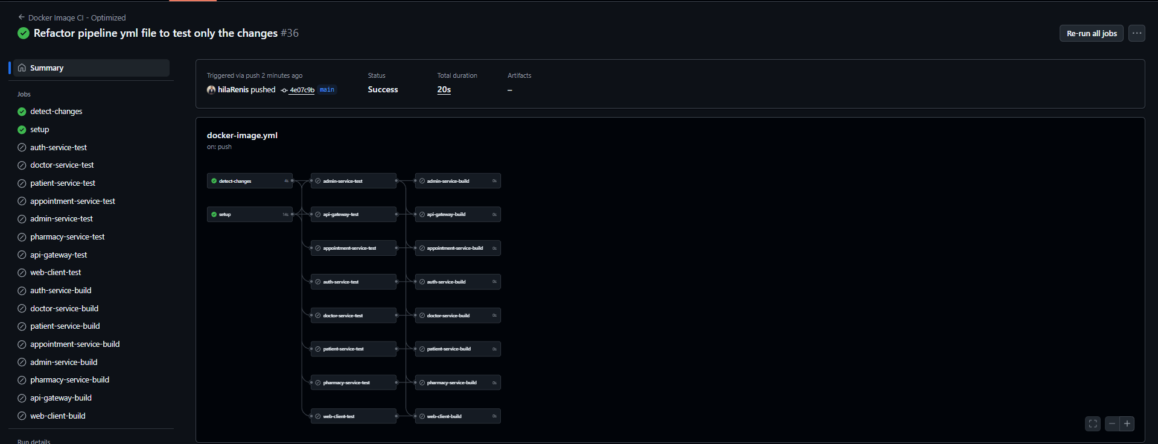

Service-Level Test Reports

Auth Service Tests
Coverage: Authentication, user registration, JWT validation
Total Tests: 25+
Key Test Scenarios:
- User registration (doctor/patient roles)
- Login with valid/invalid credentials
- JWT token generation and validation
- User CRUD operations with role-based access
- Email uniqueness validation
- Password hashing and verification

Sample Test:
await test('POST /auth/login - successful login', async () => {
const res = await makeRequest('POST', '/auth/login', {
body: { email: 'john@test.com', password: 'pass123' }
});
assert.strictEqual(res.status, 200);
assert(res.body.token);
});

Admin Service Tests
Coverage: Administrative operations, user management, statistics
Total Tests: 35+
Key Test Scenarios:
- Doctor CRUD operations
- Patient CRUD operations
- Doctor-patient assignment/unassignment
- Appointment management (create/update/delete)
- System statistics retrieval
- Pagination and sorting for lists
- Role-based access control (admin-only operations)

Appointment Service Tests
Coverage: Appointment scheduling, conflict detection, status management
Total Tests: 30+
Key Test Scenarios:
- Appointment creation by patient/doctor/admin
- Time slot conflict detection
- Appointment approval/denial by doctors
- Appointment cancellation by patients/doctors
- List appointments (all/mine)
- Update appointment details
- Validate time range constraints

Sample Test - Conflict Detection:
await test('POST / - 409 on conflict', async () => {
// Mock existing appointment in same time slot
mockDb.query = async function(sql) {
if (sql.includes('starttime')) return { rows: [{ id: 'existing' }] };
};

const res = await makeRequest('POST', '/', {
user: { sub: 'patient-1', role: 'patient' },
body: {
doctorUserId: 'doctor-1',
startTime: '2025-12-01T10:00:00Z',
endTime: '2025-12-01T10:30:00Z'
}
});

assert.strictEqual(res.status, 409); // Conflict detected
});

Doctor Service Tests
Coverage: Doctor schedules, patient management, prescriptions
Total Tests: 20+
Key Test Scenarios:
- Schedule creation and retrieval
- Patient list with pagination/sorting/search
- Patient profile retrieval
- Patient creation by doctor
- Prescription request approval/denial
- Role-based access (doctor-only operations)

Patient Service Tests
Coverage: Patient profiles, prescription requests
Total Tests: 20+
Key Test Scenarios:
- Profile creation (self/by doctor/by admin)
- Profile retrieval and deletion
- Prescription request submission
- Prescription request status tracking
- Internal endpoints for service communication
- Profile conflict prevention (409 errors)

API Gateway Tests
Coverage: Request routing, authentication, authorization
Total Tests: 20+
Key Test Scenarios:
- JWT token validation
- Request routing to correct services
- Role-based access control enforcement
- X-User header forwarding
- Public vs protected endpoints
- HTTP method proxying (GET/POST/PUT/DELETE)
- Error handling for invalid tokens

E2E Tests (Web Client)
Coverage: Critical user workflows
Total Tests: 3 workflows
Test Scenarios:
- Authentication Flow - Admin and doctor login validation
- Access Control - Role-based permissions verification
- Doctor Workflow - Patient management and scheduling
Test Modes:
- Mock Mode: No Docker required, instant execution
- Integration Mode: Full stack with Docker containers

Test Integration Architecture

Integration Strategy Overview
The HealthConnect system implements multiple levels of test integration to ensure seamless operation across all components.
┌─────────────────────────────────────────────────────────────┐
│ CI/CD Pipeline │
├─────────────────────────────────────────────────────────────┤
│ Change Detection → Tests → Integration → Deploy │
└─────────────────────────────────────────────────────────────┘
↓ ↓ ↓
[Services] [Coverage] [SonarCloud]

Service-to-Service Integration Testing
Communication Patterns:
API Gateway Integration
  - Routes requests to appropriate microservices
  - Validates JWT tokens before forwarding
  - Adds x-user header for downstream services
  - Tested with mock backend services
Inter-Service Communication
  - Admin Service ↔ Auth Service (user management)
  - Admin Service ↔ Patient Service (profile creation)
  - Admin Service ↔ Appointment Service (scheduling)
  - Doctor Service ↔ Patient Service (prescription requests)
  - All services ↔ Kafka (event-driven communication)
Database Integration
  - Each service has independent database schema
  - Tests use mocked database queries
  - Production uses PostgreSQL with connection pooling

Event-Driven Integration (Kafka)
Kafka Topics Used:
Topic | Producer | Consumer | Purpose
user.created | Auth Service | Admin Service | User registration events
user.updated | Auth Service | All Services | Profile updates
user.deleted | Auth Service | All Services | Cleanup operations
appointment.created | Appointment Service | Doctor/Patient Services | Notifications
appointment.updated | Appointment Service | All Services | Status changes
prescription.requested | Patient Service | Doctor Service | Prescription workflows
Kafka Mock Strategy:
const mockKafka = {
publishedEvents: [],
publishEvent: async function(topic, payload, options) {
mockKafka.publishedEvents.push({ topic, payload, options });
}
};
Tests verify that correct events are published without requiring actual Kafka infrastructure.

API Gateway Integration Flow
Client Request
↓
API Gateway (Port 8080)
├→ JWT Validation
├→ Role Check
├→ Add x-user header
└→ Route to Service
↓
┌────┴─────────────────┐
↓ ↓
Auth Service Admin Service
(Port 3001) (Port 3006)
↓ ↓
Database ┌─────┴──────┐
↓ ↓
Patient Service Doctor Service
(Port 3002) (Port 3003)
Gateway Test Example:
await test('Forwards x-user header to backend services', async () => {
const res = await makeRequest({
path: '/api/patients',
headers: { 'Authorization': `Bearer ${token}` }
});

assert(res.body.user); // Verify user context forwarded
assert.strictEqual(res.body.user.email, 'test@test.com');
});

Coverage Aggregation Integration
Coverage Collection Pipeline:
- Individual Service Coverage
- c8 --reporter=lcov --report-dir=./auth-coverage node auth-service/test/auth-test.js
- Upload as Artifacts
- - name: Upload Auth Coverage
- uses: actions/upload-artifact@v4
- with:
- name: auth-coverage
- path: coverage/
- Download in SonarCloud Job
- - name: Download Auth Coverage
- uses: actions/download-artifact@v4
- with:
- name: auth-coverage
- path: coverage/
- Aggregate Analysis
- sonar.javascript.lcov.reportPaths=coverage/lcov.info,
- auth-service/coverage/lcov.info,
- admin-coverage/lcov.info,
- ...

Docker Integration Testing
Container Setup:
- Each service has a Dockerfile
- Services communicate via Docker network
- Environment variables configured via .env
- Health checks ensure service readiness

Build and Push Integration:
- name: Build and push Auth Service image
uses: docker/build-push-action@v6
with:
context: ./auth-service
push: true
tags: |
${{ secrets.DOCKER_USERNAME }}/auth-service:latest
${{ secrets.DOCKER_USERNAME }}/auth-service:${{ github.sha }}
cache-from: type=registry,ref=.../buildcache
cache-to: type=registry,ref=.../buildcache,mode=max

SonarCloud Integration

Configuration
SonarCloud has been integrated to provide continuous code quality monitoring:
# sonar-project.properties
sonar.projectKey=h1laRents_HealthConnect_v2
sonar.organization=h1larents

# Coverage
sonar.javascript.lcov.reportPaths=coverage/lcov.info,auth-service/coverage/lcov.info,admin-coverage/lcov.info,appointment-coverage/lcov.info,doctor-coverage/lcov.info,patient-coverage/lcov.info,api-gateway-coverage/lcov.info

GitHub Actions Integration
sonarcloud-analysis:
runs-on: ubuntu-latest
needs: [detect-changes, auth-service-test, admin-service-test, ...]
if: |
always() &&
(needs.auth-service-test.result == 'success' ||
needs.admin-service-test.result == 'success' || ...)
steps:
- name: Download Coverage Artifacts
uses: actions/download-artifact@v4
with:
name: auth-coverage
path: coverage/
continue-on-error: true

- name: SonarCloud Scan
uses: SonarSource/sonarcloud-github-action@e44258b109568baa0df60ed515909fc6c72cba92
env:
GITHUB_TOKEN: ${{ secrets.GITHUB_TOKEN }}
SONAR_TOKEN: ${{ secrets.SONAR_TOKEN }}

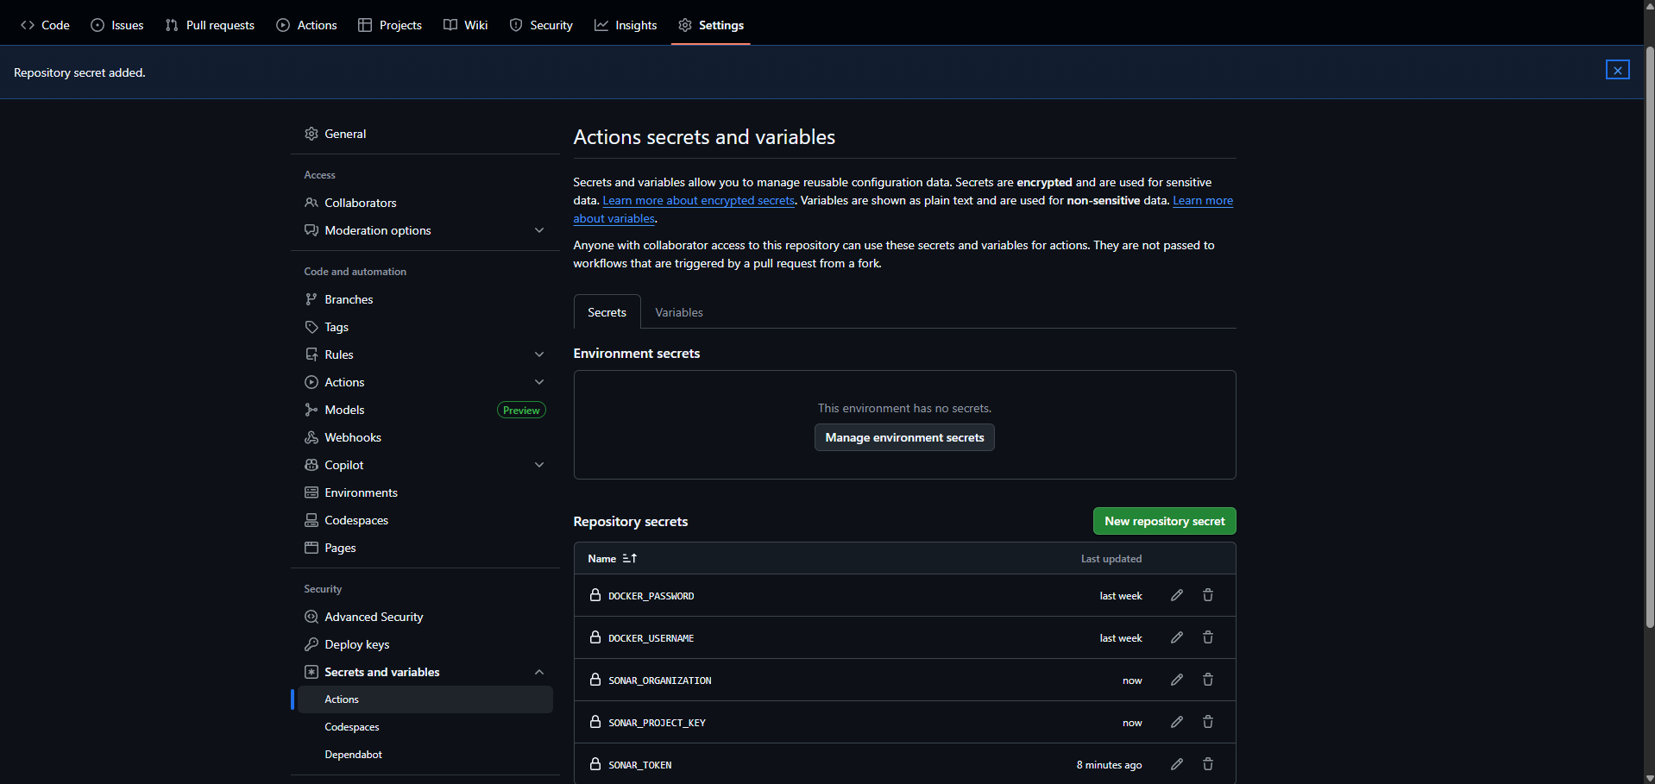

Mock Strategy

Database Mocking
Most services use a consistent database mocking strategy:
const originalQuery = async function(sql, params) {
mockDb.queries.push({ sql, params });
const sqlLower = sql.toLowerCase();

if (sqlLower.includes('insert')) {
return mockDb.mockResults['INSERT'] || { rows: [], rowCount: 1 };
}
if (sqlLower.includes('update')) {
return mockDb.mockResults['UPDATE'] || { rows: [], rowCount: 1 };
}
if (sqlLower.includes('select')) {
return mockDb.mockResults['SELECT'] || { rows: [] };
}

return { rows: [], rowCount: 0 };
};

const mockDb = {
queries: [],
mockResults: {},
query: originalQuery,
reset() {
mockDb.queries = [];
mockDb.mockResults = {};
mockDb.query = originalQuery;
}
};

Kafka Mocking
const mockKafka = {
publishedEvents: [],
publishEvent: async function(topic, payload, options) {
mockKafka.publishedEvents.push({ topic, payload, options });
},
startConsumer: async function() {
return {};
},
reset() {
this.publishedEvents = [];
}
};

Test Patterns

Test Isolation
Each test is isolated with proper setup and teardown:
async function test(name, fn) {
try {
mockDb.reset(); // Reset database state
mockKafka.reset(); // Reset event queue
await fn(); // Run test
console.log(`✓ ${name}`);
passed++;
} catch (error) {
console.error(`✗ ${name}`);
console.error(` ${error.message}`);
failed++;
}
}

HTTP Request Helper
Consistent HTTP request handling across all tests:
function makeRequest(method, path, options = {}) {
return new Promise((resolve, reject) => {
const { body, headers = {}, user } = options;

if (user) {
headers['x-user'] = JSON.stringify(user);
}

const req = http.request({
hostname: 'localhost',
port: 3001,
path,
method,
headers: {
'Content-Type': 'application/json',
...headers
}
}, (res) => {
let data = '';
res.on('data', chunk => data += chunk);
res.on('end', () => {
resolve({
status: res.statusCode,
body: data ? JSON.parse(data) : null
});
});
});

req.on('error', reject);
if (body) req.write(JSON.stringify(body));
req.end();
});
}

Role-Based Testing
Tests verify proper authorization:
await test('POST /auth/register-doctor - non-admin is forbidden', async () => {
const res = await makeRequest('POST', '/auth/register-doctor', {
user: { sub: 'doctor-1', role: 'doctor' },
body: { name: 'Dr. Smith', email: 'smith@test.com', password: 'pass123' }
});

assert.strictEqual(res.status, 403);
});

Performance Metrics

Test Execution Times
Service | Test Count | Execution Time
Auth Service | 25 | ~500ms
Admin Service | 35 | ~700ms
Appointment Service | 30 | ~600ms
Doctor Service | 20 | ~400ms
Patient Service | 20 | ~400ms
API Gateway | 20 | ~2000ms
E2E Tests | 3 | ~3000ms

CI/CD Pipeline Performance
- Change Detection: ~20s
- Setup (with cache): ~30s
- Single Service Test: 20-40s
- Docker Build (with cache): 60-90s
- SonarCloud Analysis: ~60s

Conclusion
The HealthConnect project has a solid testing foundation with comprehensive tests, automated CI/CD, and continuous quality monitoring.

Strengths
- 68.8% code coverage across all services
- Intelligent CI/CD pipeline with change detection
- Automated quality monitoring via SonarCloud
- Consistent testing patterns across microservices
- Role-based access testing ensures security
- Fast test execution

